**AIM -->**

Design an obstacle detector and distance measuring device.

**CIRCUIT DIAGRAM=**

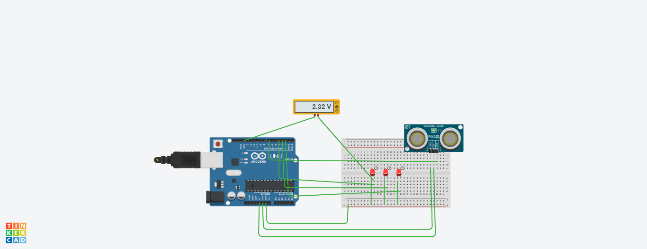

**THEORY🡺**

***Arduino*** refers to an open-source electronics platform or board and the software used to program it. **Arduino** is designed to make electronics more accessible to artists, designers, hobbyists and ayone interested in creating interact

A **breadboard** is a construction base for prototyping of electronics.

A ***circuit*** is a closed path that allows electricity to flow from one point to another. It may include various electrical components, such as [transistors](https://techterms.com/definition/transistor), resistors, and capacitors, but the flow is unimpeded by a gap or break in the circuit.

ULTRASONIC SENSOR🡺

**Ultrasonic sensors** work by emitting sound waves at a frequency too high for humans to hear. They then wait for the sound to be reflected back, calculating distance based on the time required.

DISPLAY:-

It is used to print value to analyse the variation.

***Kirchhoff's Current Law (KCL)*** is Kirchhoff's first law that deals with the conservation of charge entering and leaving a junction. ... His current law states that for a parallel path the total current entering a circuits junction is exactly equal to the total current leaving the same junction.

A ***loop*** is a programming structure that repeats a sequence of instructions until a specific condition is met. Programmers use loops to cycle through values, add sums of numbers, repeat [functions](https://techterms.com/definition/function), and many other things.

**LEARNING AND OBSERVATION=**

* Whenever the ultrasonic sensor detect any obstacle it measures the distance between the sensor and obstacle. the led get turn on and off by increasing the distance and also we can observe the variation of voltage.
* Learned about ***ultrasonic sensor*** and ***Arduino***. Circuit set up is also clear.
* Use of ultrasonic sensor for different purpose.

**PROBLEM AND TROUBLESHOOTING=**

1. Setting up a connection.
2. Errors in code.
3. Port was not selected.
4. Proper Power supply.
5. Connect display in proper pinmode.

**PRECAUTIONS🡺**

1. Don't plug **in** an LED without a current limiting resistor.
2. Don't supply it with more then 9V.
3. Circuit must be correct.
4. proper terminal should be connected in proper pinmode according to code.

**LEARNING OUTCOMES🡺**

1. Learned programming concepts using ldr along with Arduino specific programming.
2. Usage of a wide variety of hardware and components and prototype your projects using a breadboard.
3. Understand what an Arduino is and how it work and learnt how to use an Arduino safely.
4. Understand the properties of ultrasonic sensor and how it works.